Practical - 1
Practical Title: Project Initiation, Requirement Analysis, Sitemap, Wireframe, and GitHub Setup

Problem Definition: Initiate the semester-long StudentHub portal by identifying the problem scope, user roles, key modules, navigation flow, and minimum 10 pages. Create a sitemap, low-fidelity wireframe, project folder structure, README file, and GitHub repository.

Theory

What is URL and parts of URL?
Answer: URL is the address of a web page on.
Parts of URL: protocol :-https:// , domain name :-www.google.com , path :-/home

How does HTML file process in web browser?
Answer: When a user open HTML file on browser it sends request to web server to get the HTML file. After that the browser reads the code and creates a document object model it loads the file like css , javascript and images. The browser render all the files and display the whole web page on screen.

3. How will page navigation flow managed among all HTML pages?
Answer: Page navigation flow amoung HTML pages is managed using hyperlinks create with anchor tage (<a>). Each link connects one HTML page to another by specifying the destination page in the href attribute. When a user clicks the links browser opens the linked page, allowing smooth navigation between different pages of the website.

4. How will GitHub commits be maintained after each practical?
Answer: Github commits should be maintained by creating a commit after completing each practical. Each commit should include the changes made and have a clear, meaningful commit message, such as ‘added practical 1’ or ‘completed practical 2’. This helps track progress , maintain version history , and makes it easy to review or restore previous work if needed.

Implementation/ Output/Result
- Created Sitemap and wireframe
- Created a Github Reposaitory
- Design the project’s pages and structure

Evidence of Work (Screenshots)
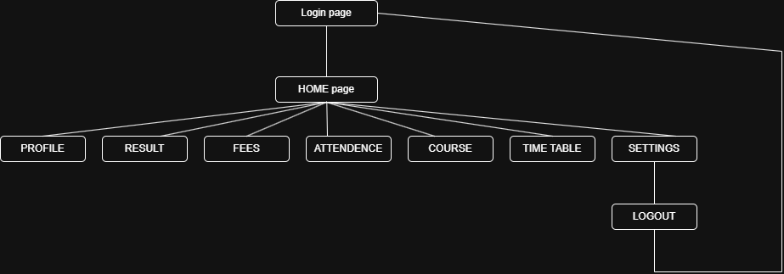
Description: it is a sitemap of student hub portal. 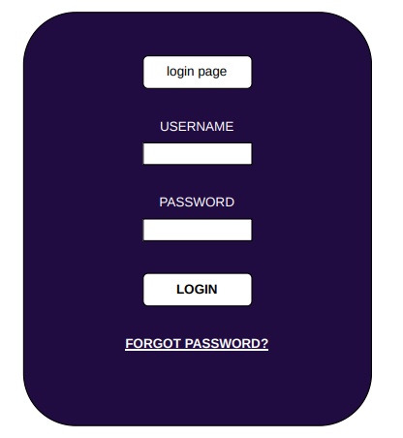
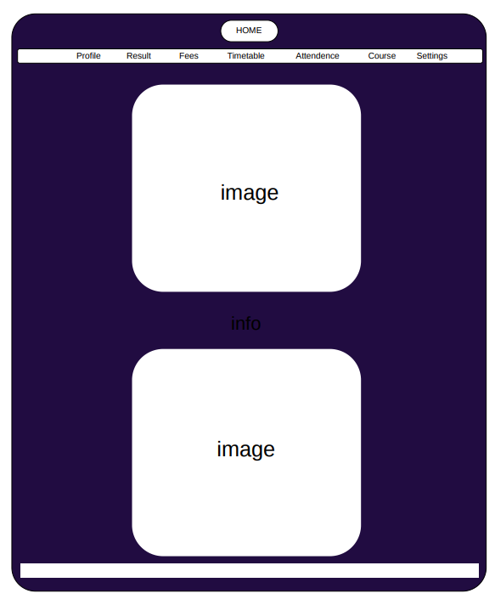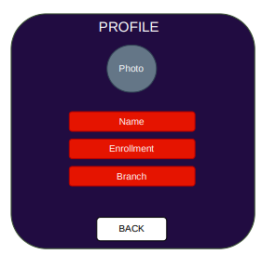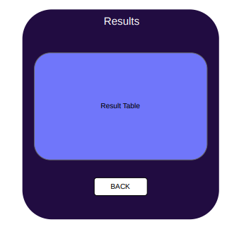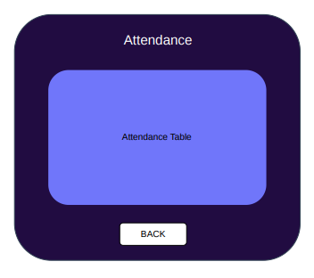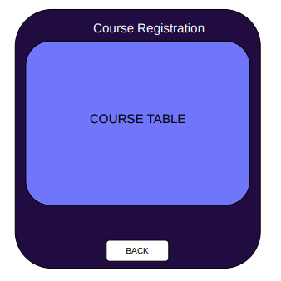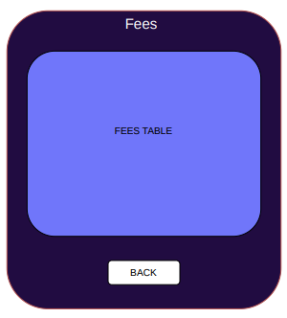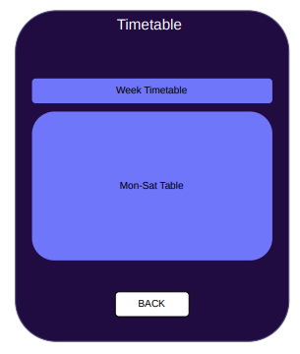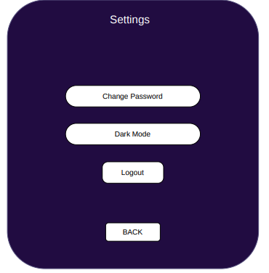

Description: this is wireframe for student hub portal’s pages.

GitHub Repository Link: https://github.com/dharmkakasaniya01/Student

Challenges Faced:
While performing this practical , I faced some difficulty in planning the website structure , creating a proper sitemap , and designing the wireframe. Initially , organizing the project folder in Github repository was also challenging but I understood the process after practical.

Learning Outcomes:

After completing the practical , I learned how to initiate a web development project by analyzing the project requirement and defining its scope. I learned how to create sitemap, wireframe for planning a website. I also learned to organize the project structure and use github to manage the project with version control and commits.

Faculty Remarks:

